About page
An old faith, seen in new light

The organisation behind the Roseville New Church is the Sydney Society of the New Church, governing and maintaining its activities. The Sydney Society of the New Church has been nourishing people’s spiritual journey for more than 150 years. Established in 1875, the Society was formed by people inspired by the teachings of the eighteenth-century Swedish scientist, philosopher, and theologian Emanuel Swedenborg. Since then, it has sought to encourage a practical Christianity centred on love to the Lord, kindness towards others, and the understanding that genuine faith finds its fulfilment in a life of useful service.

A long-standing tradition connects the Society's story with the very beginnings of European settlement in Australia. It has been widely held within the New Church that a collection of Swedenborg's theological writings travelled with the First Fleet and arrived in Sydney Cove in 1788. While historians continue to discuss the details, the tradition reflects the belief that Swedenborg’s influence was present from the colony's earliest days and forms a meaningful part of the Society's heritage.

Throughout its history, the Sydney Society has sought to make Swedenborg's vision of Christianity accessible to each new generation. His writings present a picture of God as the Lord Jesus Christ, teach that the Bible contains profound spiritual meaning, and emphasise that heaven begins within us as we freely choose lives shaped by love, wisdom, and service. These teachings continue to offer hope and practical guidance for people seeking a thoughtful and life-affirming spirituality.

Over the decades the Society has adapted to changing times while remaining faithful to its purpose. Worship services, Sunday school, Bible study, public lectures, pastoral care, and community gatherings have all played their part in fostering a community where questions are encouraged, spiritual growth is nurtured, and people from different backgrounds are made to feel at home.

A significant milestone was reached in 2025, when the Sydney Society of the New Church celebrated its 150th Anniversary of faithful service. The anniversary honoured the dedication of generations who have preserved and shared these teachings while looking forward with confidence to the future. It was both a celebration of the past and a renewed commitment to serving the spiritual needs of those who participate in its activities.

Today, the Sydney Society warmly welcomes all who are searching for a deeper understanding of God, the Bible, and the purpose of life. Whether you are exploring Swedenborg's writings for the first time or are simply looking for a thoughtful and friendly Christian community, we invite you to discover a tradition that has quietly enriched lives in Sydney for over a century and a half.

The Roseville New Church is part of a larger network
The Roseville New Church is part of a larger network of like-minded communities around Australia and New Zealand. To find out more visit https://newchurch.net.au/.

Beliefs
If you are wishing to explore core beliefs of our communities visit
https://newchurch.net.au/beliefs.
What’s helpful with this link is that you can ask questions via the New Church Chatbot at the bottom of the page.

Past Ministers
I like the idea of having a picture of the minister with their wife in this section for Howard and Julian. What are your thoughts? I’ve provided a draft of the accompanying info. If you like this idea of mentioning Howard and Julian, I’ll send the draft to Howard and Julian to rewrite it.
Rev. Howard A. Thompson
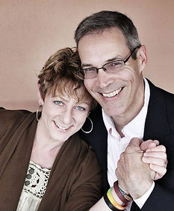
Originally from the United States, I spent over 20 years in the insurance and risk management industry before feeling a calling to ministry in 2007. It was 10 years before this calling that my wife Debra and I were choosing a primary school for our first child and were introduced to the faith of the New Church. The New Church's emphasis on God's love and compassion and the importance of faith in everyday life resonated with me and ultimately led to my decision to leave my business and pursue theological school.

As Revelation 3:20 reminds us, the Lord is constantly pressing to be received by us, but we can struggle to listen amidst the busyness of life. Through personal events and decisions, I learned that making choices in the best interest of others can ultimately transform our own lives. It is my belief that the Lord's love and guidance are present in all aspects of our lives, whether it be at home with our families or at work.

Outside of ministry, I enjoy staying active with CrossFit workouts and spending time in nature, particularly at the beach and in my garden.

In early June 2026, he and his wife Debra returned to America, to start a new chapter in their lives.

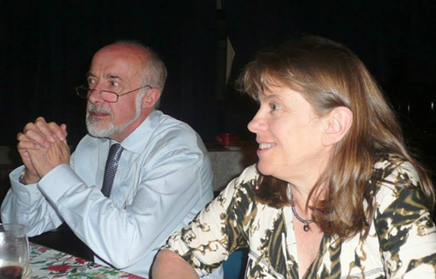
Rev. Julian Duckworth
Julian and his wife Ruth arrived from England to be part of the Roseville New Church. They have four grown up children. Julian spent ten years in primary school teaching, specialising in music, and Ruth has been a physiotherapist. They both take an active part in school programs and opened the church to the local community in a number of ways. Their vision is to help people on their spiritual path and to provide people with the freedom and opportunity to do so.
Julian has a great love for the Bible and the symbolism lying below the surface. He is familiar with Hebrew and Greek and enjoys using the words of the Bible to shed more light on our spiritual life. He says that Swedenborg’s spiritual teachings are a great joy and a bright light because they teach us how God is most relevant in the way we choose to live.

I think it’s good to include Ian as it shows there are New Church Australian ministers and it points to a New Church College.

Rev. Ian Arnold
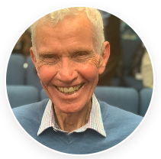
Ian grew up in Melbourne and, already a young Christian during High School years was introduced to the teachings of Emanuel Swedenborg through a friend when in his late teens. Feeling a call to ministry he travelled to the UK, via experience in missionary work in South Africa in 1961. Following studies at The New Church College and London University Ian was ordained in 1965 and married the love of his life, Margaret, the same year, they becoming parents of 5 children. He has served as a Pastor in England, Mauritius, in Adelaide and in Sydney. In 1991 he became Principal of The New Church College in the UK and, returning home, he served as Principal of The Australian New Church College for 10 years. He retired in 2014.

Manager of the Swedenborg Centre
I can ask Joe for a short description and picture

Do we add
Secretary of the Sydney Society
Treasurer of the Sydney Society
I think it’s a good idea.
Are there others as well like Charlie?

